15.16: a)
b) c) The speed is larger by a factor of 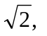and so for the same wavelength, the frequency must be multiplied by 